1.

Singly Linked List Header File:
1 #include <stdio.h>
2 #include<stdlib.h>
3
4 typedef struct node* nxtptr;
5
6 typedef struct node{
7
8 int n;
9 nxtptr next;
10 }node;
11
12
13
14 nxtptr createHead(){
15 nxtptr head;
16 head = (nxtptr)malloc(sizeof(node));
17
18 head->next = NULL;
19 return head;
20 }
21
22
23 nxtptr createNode(nxtptr previous){
24 nxtptr a;
25 a = (nxtptr)malloc(sizeof(node));
26 printf("Enter the number: ");
27 scanf("%d",&a->n);
28 a->next = NULL;
29
30 previous->next = a;
31 return a;
32 }
33
34 void createn(int k,nxtptr head){
35 nxtptr previous = head;
36 int i;
37 for(i=0;i<k;i++){
38 previous = createNode(previous);
39
40 }
41 }
42
43 nxtptr find(int n,nxtptr head){
44 nxtptr previous = head->next;
45 nxtptr retVal = NULL;
46 while (previous->next != NULL){
47 if(previous->next->n== n){
48 retVal = previous;
49 break;
50 }
51 previous=previous->next;
52 }
53 return retVal;
54 }
55
56 void insert(nxtptr previous,nxtptr head){
57 previous = previous->next;
58 nxtptr tmp = previous->next;
59 previous = createNode(previous);
60 previous->next = tmp;
61 printf("Inserted\n");
62 }
63
64 void insertEnd(nxtptr head){
65 nxtptr previous = head->next;
66 while (previous->next != NULL){
67 previous=previous->next;
68 }
69 createNode(previous);
70 }
71
72 void insertStart(nxtptr head){
73 nxtptr tmp = head->next;
74 createNode(head);
75 head->next->next = tmp;
76
77 }
78 void delete(int n,nxtptr head){
79 nxtptr previous;
80 if (head->next->n == n){
81 previous = head;
82 }
83 else {
84 previous = find(n,head);
85 }
86 nxtptr delel = previous->next;
87 previous->next = delel->next;
88 free(delel);
89 printf("Deleted\n");
90 }
91 void countOccurence(int n, nxtptr head){
92 nxtptr previous = head->next;
93 int count = 0;
94 while (previous != NULL){
95 if(previous->n== n){
96 count++;
97
98 }
99 previous=previous->next;
100 }
101 printf("Element Appears %d times\n",count);
102 }
103
104 void display(nxtptr head){
105 nxtptr previous = head->next;
106 while(previous != NULL){
107 printf("%d ",previous->n);
108 previous=previous->next;
109 }
110 printf("\n");
111 }
112
113 int size(nxtptr head){
114 nxtptr previous = head->next;
115 int count = 0;
116 while(previous != NULL){
117 count++;
118 previous = previous->next;
119 }
120 return count;
121 }

Singly Linked List Application File:

1 #include <stdio.h>
2 #include "singlylinked.h"
3
4 void main(){
5 int choice =1;
6 nxtptr head = createHead();
7 createn(5,head);
8 display(head);
9 int n;
10 while(choice!=0){
11 printf("1.Add in Front, 2.Add at End, 3.Add after a given Element, 4.Delete, 5. Count Occurences, 6.Display, 7.Size 0.Exit\n");
12 scanf("%d",&choice);
13 switch(choice){
14 case 1: insertStart(head); break;
15 case 2: insertEnd(head); break;
16 case 3: printf("Enter Number after which to add: ");
17 scanf("%d",&n);
18 insert(find(n,head),head); break;
19 case 4: printf("Enter Number to Delete: ");
20 scanf("%d",&n);
21 delete(n,head); break;
22 case 5: printf("Enter Number to Count Occurences: ");
23 scanf("%d",&n);
24 countOccurence(n,head); break;
25 case 6: display(head); break;
26 case 7: printf("Size of List is %d\n",size(head));
27
28
29
30 }
31 }
32 }

Input/Output:

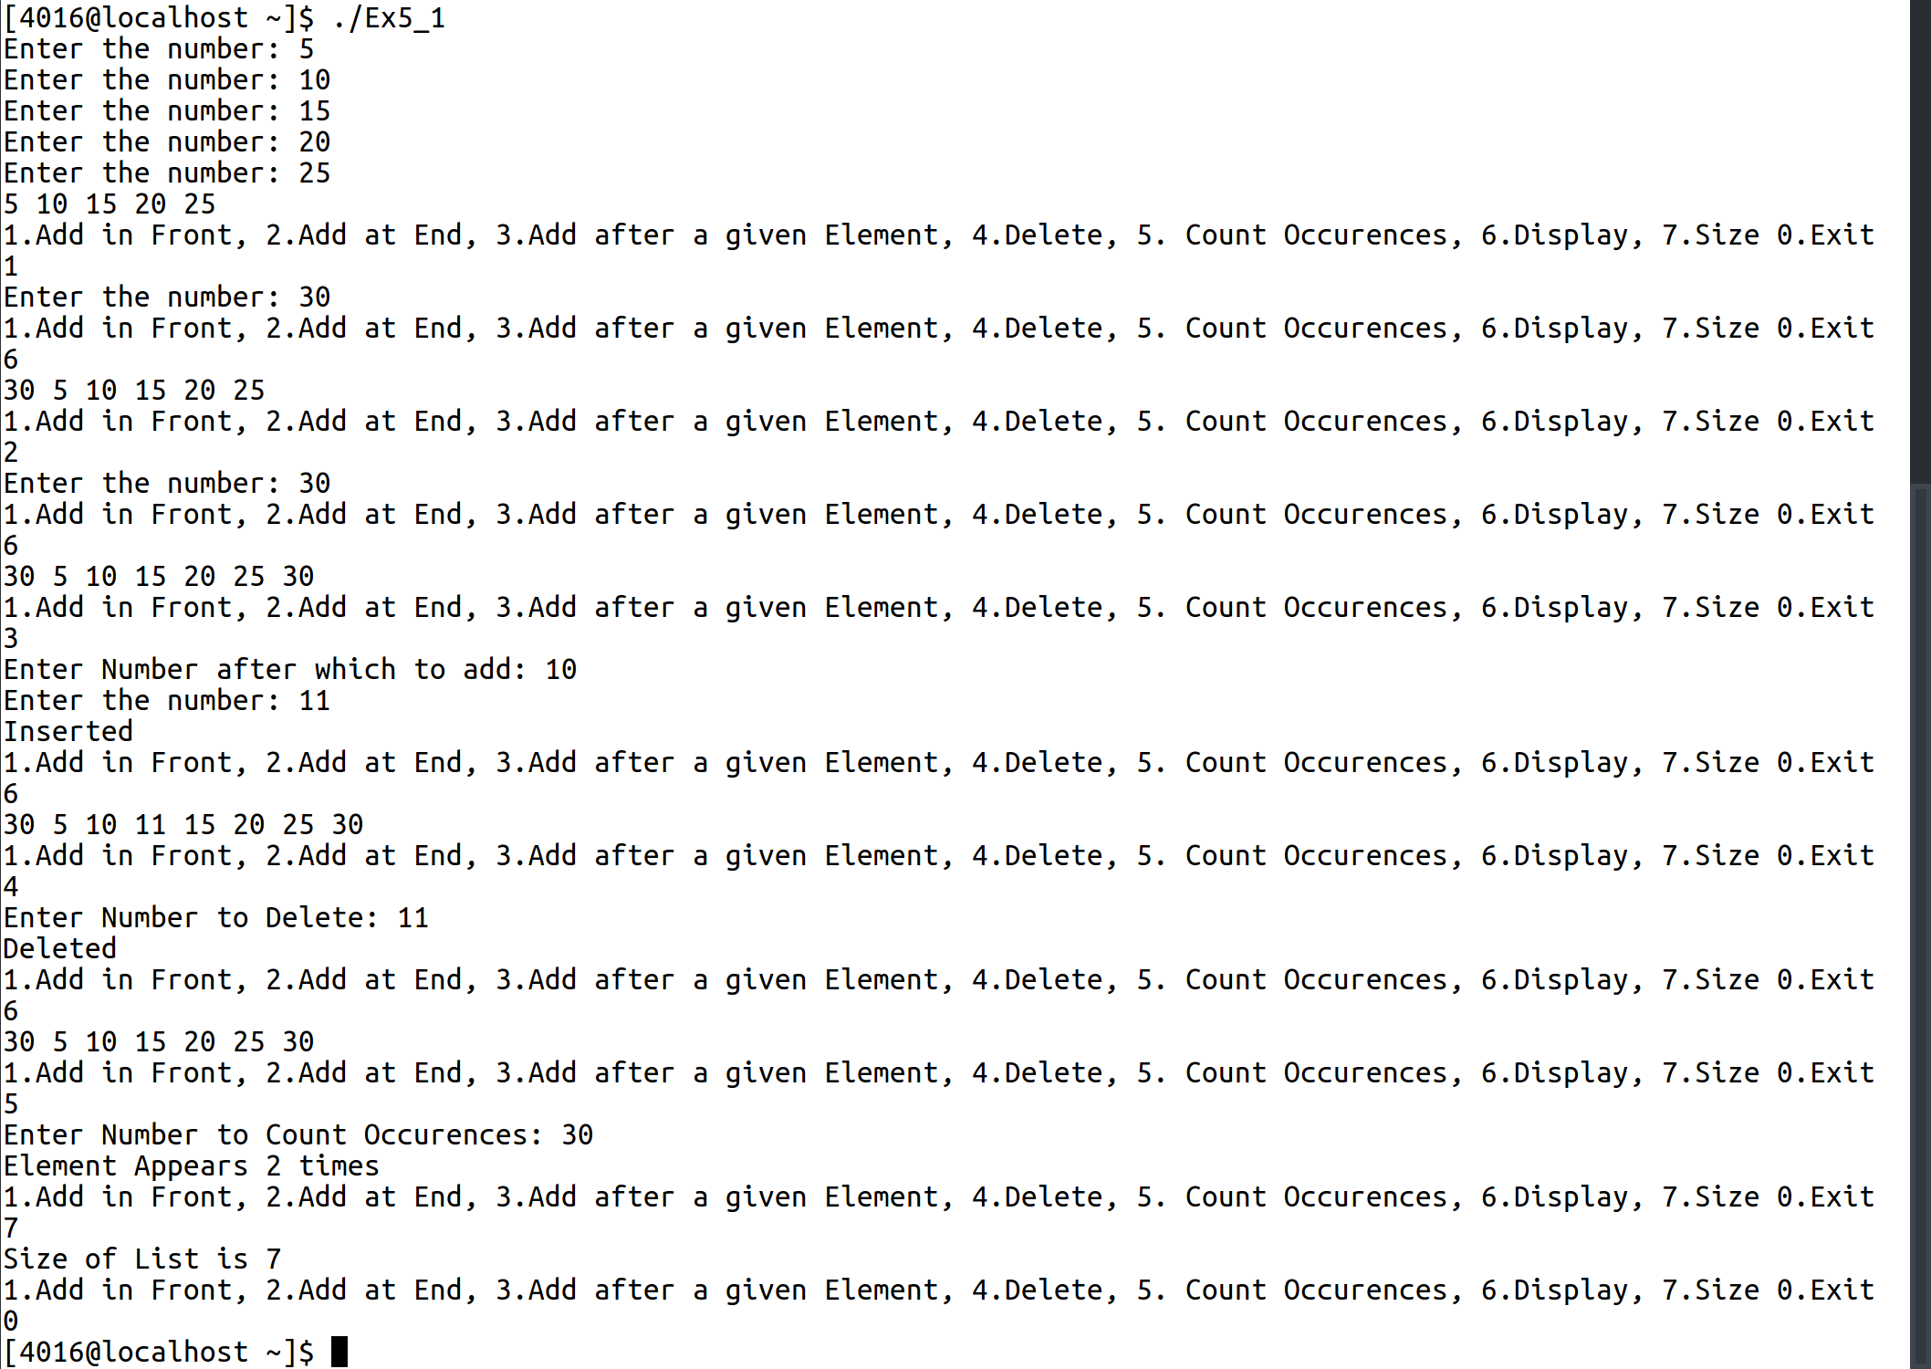

2.

Doubly Linked List Header File:

1 #include <stdio.h>
2 #include <stdlib.h>
3 #include <string.h>
4
5 typedef struct node* nxtptr;
6
7 typedef struct node{
8
9 char n[200];
10 nxtptr next;
11 nxtptr prev;
12 }node;
13
14
15
16 nxtptr createHead(){
17 nxtptr head;
18 head = (nxtptr)malloc(sizeof(node));
19
20 head->next = NULL;
21 head->prev = NULL;
22 return head;
23 }
24
25
26 nxtptr createNode(nxtptr previous){
27 nxtptr a;
28 a = (nxtptr)malloc(sizeof(node));
29 printf("Enter the name: ");
30 scanf("%s",&a->n);
31 a->next = NULL;
32 a->prev = previous;
33 previous->next = a;
34 return a;
35 }
36
37 void createn(int k,nxtptr head){
38 nxtptr previous = head;
39 int i;
40 for(i=0;i<k;i++){
41 previous = createNode(previous);
42
43 }
44 }
45
46 nxtptr find(char n[200],nxtptr head){
47 nxtptr previous = head->next;
48 nxtptr retVal = NULL;
49 while (previous != NULL){
50 if(strcmp(previous->n,n)== 0){
51 retVal = previous;
52 break;
53 }
54 previous=previous->next;
55 }
56 return retVal;
57 }
58
59 void insert(nxtptr previous,nxtptr head){
60
61 nxtptr tmp = previous->next;
62 previous = createNode(previous);
63 previous->next = tmp;
64 previous->next->prev = previous;
65
66 printf("Inserted\n");
67 }
68
69
70 void delete(char n[200],nxtptr head){
71 nxtptr previous = find(n,head);
72 if(previous->next == NULL){
73 previous->prev->next = NULL;
74 free(previous);
75 }
76 else{
77 previous->prev->next = previous->next;
78 previous->next->prev = previous->prev;
79 free(previous);
80 printf("Deleted\n");
81 }
82 }
83
84
85 void display(nxtptr head){
86 nxtptr previous = head->next;
87 while(previous != NULL){
88 printf("%s ",previous->n);
89 previous=previous->next;
90 }
91 printf("\n");
92 }
93
94 void displayPN(char a[200],nxtptr head){
95 nxtptr elem = find(a,head);
96 if(elem->next == NULL){
97 printf("Previous Name: %s\n",elem->prev);
98 }
99 else if(elem->prev == head){
100 printf("Next Name: %s\n",elem->next);
101 }
102 else{
103 printf("Previous Name: %s, Following Name: %s \n",elem->prev,elem->next);
104 }
105 }

Doubly Linked List Application File:

1 #include <stdio.h>
2 #include "doublylinked.h"
3
4 void main(){
5 int choice =1;
6 nxtptr head = createHead();
7 createn(5,head);
8 display(head);
9 char n[200];
10
11 while(choice!=0){
12 printf("1.Insert, 2.Search, 3.Delete, 4. Display, 5.Display Previous and Next \n");
13 scanf("%d",&choice);
14 switch(choice){
15 case 1: printf("Enter Name to insert after: ");
16 scanf("%s",&n);
17 insert(find(n,head),head); break;
18 case 2: printf("Enter Name to search for: ");
19 scanf("%s",&n);
20 if(find(n,head)){
21 printf("It is found at address %p",find(n,head));
22 }
23 else{
24 printf("Not Found\n");
25 }
26 break;
27 case 3: printf("Enter Name to Delete: ");
28 scanf("%s",&n);
29 delete(n,head); break;
30 case 4: display(head); break;
31 case 5: printf("Enter Name to display neighbouring elements: ");
32 scanf("%s",&n);
33 displayPN(n,head);break;
34
35
36
37 }
38 }
39 }

Input/Output:
